Albemarle County Public Schools
Department of Human Resources


School Year 2011-2012 Annual Report
Annual Report
2012-2013
October 1, 2011 – September 30, 2012

October 1, 2011 – September 30, 2012

The Albemarle County Public Schools Department of Human Resources is proud to share with you the School Division Human Resources Annual Report. In this report, you will find information on the School Division’s workforce as well as some of the Human Resources Department’s accomplishments for the school year 2012-2013.

As the Director of Human Resources for Albemarle County Government and Albemarle County Public Schools, my primary responsibility is to lead a team dedicated to the goal of recruiting, training and retaining world-class professionals. Our department is structured in a client‐group model: small staff teams work closely with a designated customer segment (elementary schools, secondary schools, school support, and local government) to better understand their needs and provide customized HR solutions tailored to those specific needs. We restructured several positions this year to better align with the School Division’s vision, mission and goals.

Several key initiatives and accomplishments throughout this past year include:

- Increased our hiring of diverse teachers by 60% (of the 128 teachers this year 12% are minorities)
- Reviewed all positions in the Transportation Department to ensure appropriate classification
- Implemented a new EAP vendor, Optima EAP, which provides enhanced services for employees and their family members at a lower cost
- Provided in-house training for School Division classified employees, resulting in classified employees attendance in 96 different classes, totaling more than 1,122 hours of class time
- Participated in successful implementation of the new Human Resources/Payroll System (Great Plains)

Looking forward, we will continue to focus on the strategic goal to recruit, retain and develop a diverse cadre of the highest quality teaching personnel, staff, and administrators.
Lorna Gerome
Director of Human Resources
December 2012
Table of Contents

Teacher Report 3
Administrator Report 11
Classified Staff Report 14
Exit Surveys 18
Compensation and Benefits 19
Going Forward 21
Teacher Report
Recruitment and Selection

The Human Resources Department continues to support the Albemarle County Public School Division Strategic Goal #3 in working to recruit, select, and retain the best talent possible. From July 1, 2012 through September 30, 2012, the Albemarle County Public School Division hired 128 teachers. This is the largest number of new teacher hires in five years. This represents a 22% increase from last year and a 77% increase from 2010. Almost eleven percent of the teaching staff for 2012-2013 are new hires.

New Teacher Hires
2008 | 2009 | 2010 | 2011 | 2012
114 | 111 | 72 | 105 | 128

Of the 128 teachers hired:
- 16 (12%) are minorities
- 92 (72%) are full-time; 36 (28%) are part-time
- 88 (69%) had previous teaching experience
- 50 (39%) have more than five years of teaching experience
- 66 (52%) had previously taught in Virginia
- 40 (31%) are starting their teaching careers in ACPS
- 90 (70%) have at least a Master’s degree
- 93 (73%) are female; 35 (27%) are male
- 69 (54%) have three or more years of teaching experience
- 55 (43%) were hired for the elementary level
- 73 (57%) were hired for the middle and high school (secondary) levels.

This is the largest number of minority hires in five years and is also the largest percentage of new hires that are minorities. Forty (31%) of the new hires are beginning their teaching careers in ACPS, while 19 (15%) have one or two years of teaching experience, 19 (15%) have three to five years of teaching experience, and 50 (39%) have more than five years of teaching experience.

From October 1, 2011 through September 30, 2012, the Human Resources Department had 1,015 individuals apply for teaching positions. This is a nine percent increase in applications from the 2010-2011 school year. The chart below provides information about the applicants.

Teacher Applications
 | Number of Applications | Percentage of Total | Identified as Licensed in VA | Percentage Identified as Licensed
All | 1015 | 100 | 747 | 74
White | 866 | 85.3 | 651 | 75
No Response | 86 | 8.5 | 57 | 66
Minority | 63 | 6.2 | 39 | 62

Each applicant has the choice to self‐identify his/her ethnicity. To be identified as "Licensed in Virginia", the applicant held a Virginia teaching license at the time of the submission of their application or obtained one by the end of September 2012.

Highly Qualified Teachers

The No Child Left Behind law requires 100% of those teaching in “core” subject areas to meet specific criteria in order to be defined as “Highly Qualified”. The Albemarle County Public School Division had 98.7% of its teachers meet this requirement for the 2011‐2012 school year. This was the first year that Virginia used a new system to identify highly qualified teachers. Concerted efforts were made during the summer hiring process to make sure that all new teachers would be considered Highly Qualified and that all teachers in the Division only teach subjects in which they are endorsed.

Minority Staffing

Currently, there are 99 minority teachers. Of the 128 teachers hired this year, 16 (12%) are minorities, compared to ten minorities hired last year. Our efforts to recruit and hire diverse teachers appear to be paying off, as this represents a 60% increase in minority new hires.

The first‐year minority teachers are graduates of the following schools (undergraduate and graduate respectively if applicable):
- University of Virginia
- Hampton University
- James Madison University
- College of William and Mary

Veteran minority teachers are graduates of (again listed by undergraduate and graduate school):
- University of Virginia
- Winston-Salem State University
- Liberty University
- Texas State University
- George Mason University
- Longwood University
- University of Michigan
- Roanoke College
- Lynchburg College
- Christopher Newport University
- Grove City College

As can be seen in the following chart, college and university schools of education do not produce a large number of minority graduates. Most counties and cities throughout the Commonwealth are striving to increase minority representation in their teaching staff.

Virginia Schools of Education Graduates 2011 and 2012
School | Total # of Education Graduates 2011 | Total Minority Education Graduates 2011 | Percent 2011 | Total # of Education Graduates 2012 | Total Minority Education Graduates 2012 | Percent 2012
UVA | 239 | 30 | 13%
JMU | 244 | 17 | 7%
Virginia Tech | 118 | 8 | 7% | 104 | 2 | .01%
Mary Baldwin | 141 | 4 | 3%
William & Mary |  |  |  | *85 | 10 | 11%
Longwood | -- | -- | -- | 346 | 33 | 9.5%

-- No information available
*8 students did not respond

A highlight of the recruitment season was rebuilding the relationship we have with the College and William and Mary as we were able to gain some racial and gender diversity for some of our classrooms with their graduates.

Eight percent of the teachers in the Division are minorities, as compared to 17% of the residents and 30% of the student population. The statistical breakdowns can be seen in the following graph.

The School Division continues to value the importance of diversity within the teaching staff. In a continuing effort to increase diversity, Albemarle County Public Schools will remain a partner with the African American Teaching Fellows, a consistent hiring resource outside the traditional means of recruiting. Beyond this, we will continue to target specific professional communities to address specific teaching needs for our Division.

Retirements

From October 1, 2011 through September 30, 2012, 31 teachers retired compared to 36 the previous year. To be eligible for full Virginia Retirement Service (VRS) retirement with unreduced benefits, teachers must have at least 30 years of full-time service in VRS and be at least 50 years old. This year, 48% of the retirees received full benefits compared to 58% the previous year. The following table shows the number of teacher retirements for the past five years. The average age of teachers retiring after the 2011-2012 school year was 61. Over the last five years the average retirement age has ranged between 58.6 and 61. The age of this year’s retirees ranged from 51 to 70.

Teacher Retirements 2008-2012
2008 | 2009 | 2010 | 2011 | 2012
33 | 41 | 30 | 36 | 31

The County’s Voluntary Early Retirement Incentive Program (VERIP) is designed for employees who have already met VRS retirement eligibility standards, but are not yet 65. This program provides eligible employees an early retirement option consisting of two types of benefits, both payable on a monthly basis for five years or until age 65, whichever comes first:

- Medical Contribution - A stipend equivalent to the School Board’s medical insurance contribution given to active full-time employees
- VERIP Stipend - A benefit based on the difference between the estimated VRS benefit the employee would receive by retiring early and the benefit the employee would receive with five additional years of service

Beginning July 1, 2012, a phase-out schedule was implemented to reduce the amount of the VERIP stipend by 20% each year until it is eliminated altogether in 2016-2017. The decision to eliminate the stipend was based on market data that indicated current benefits exceeded market levels. A cross-departmental workgroup established the phase-out schedule. Retirees will continue to receive the medical contribution during their years of VERIP eligibility.

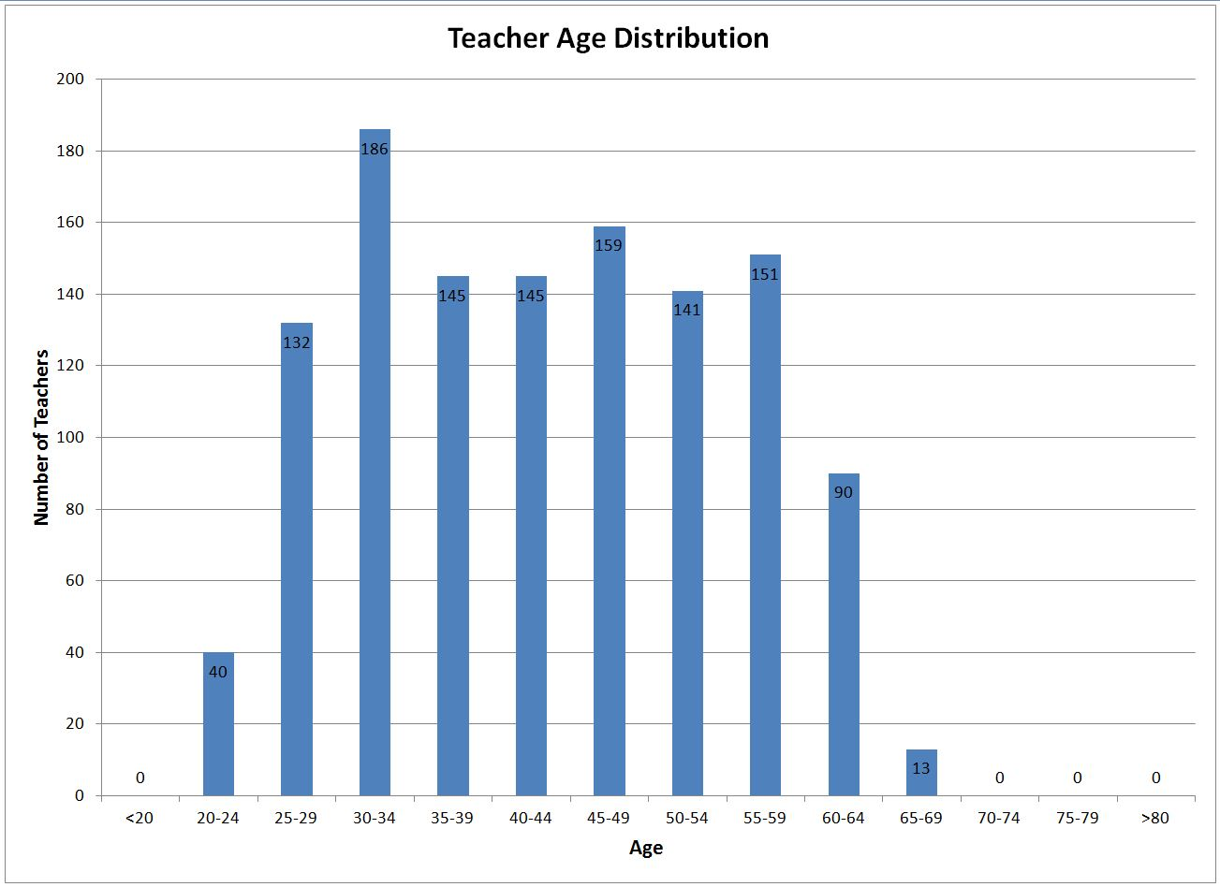
Note: The number in each bar is the actual number of teachers in the School Division.

The chart above shows the age distribution of the teaching staff. Thirty-four percent of the teachers in the School Division are age 50 or older. The cumulative number of teachers (both full and part‐time) eligible to take advantage of VERIP over the next three years is as follows:
- June 2012: 277
- June 2013: 301
- June 2014: 328

The table below shows the number of full-time teachers who are currently eligible to retire with unreduced VRS benefits and the additional teachers who will be eligible for full retirement at the end of each school year. At the end of the 2011-2012 school year, 69 teachers were eligible to retire with full benefits. Only 15 of those teachers chose to retire.

Teachers Eligible to Retire With Full VRS Payments
 | Current | End of  2011-12 | End of  2012-13 | End of  2013-14 | End of  2014-15 | End of  2015-16
Eligible to Retire with Full Benefits | 54 | 15 | 18 | 13 | 15 | 15
Running Total | 54 | 69 | 88 | 101 | 116 | 131

It should also be noted that as of September, 2012, there were 109 full-time teachers at the pay step of T30 or above. This means that there are an additional 55 teachers who received credit for previous teaching experience or may have taught part time and are nearing retirement age, even though they may not be eligible at this time for an unreduced retirement from VRS. The average age of the 109 teachers is 59; the range of ages is 52-67.

Retention

Teacher retention rates over the past five years have been between 89.1% and 92.1%. For the 2011-2012 year, the retention rate was 90.8%. From October 1, 2011 through September 30, 2012, 108 teachers did not return to the School Division.

The graph below provides information on teacher turnover based on years of teaching experience in Albemarle County. During 2011-2012, 40 teachers who left the School Division had less than four years teaching in the Albemarle County Public Schools. This is the second lowest number of most recently hired teachers to leave the School Division in the past five years. This could be a result of better initial selection of teaching staff, the continued professional development provided by the the instructional coaches as part of the novice teacher mentor program, the increased use of Professional Learning Communities, and the revised RIF policy.

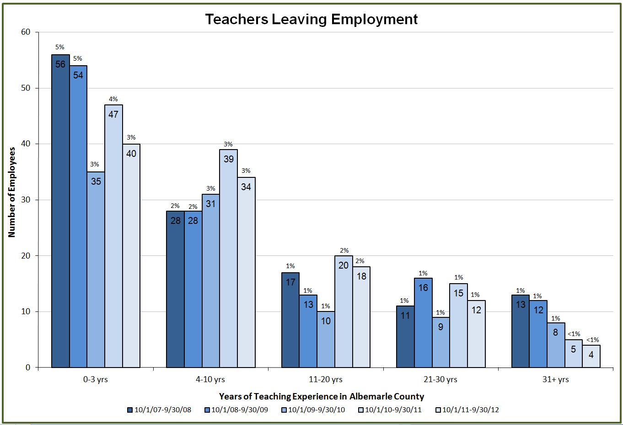
Note: The number in each bar is the actual number of teachers who left the School Division, while the number above is the percentage of the total number of teachers in the School Division.

Of the 108 teachers who left the School Division in the 2011-2012 school year, 31 (28.7%) left for retirement, while 77 (71.3%) left for other reasons. As the chart below shows, the overall number of teachers leaving the School Division was the second lowest in five years. The percentage of teachers leaving with less than four years of teaching in the County Schools was the lowest in five years.

Exiting Teachers 2008-2012
Year | Teachers Leaving | Teachers Retiring | Percent of Teachers Retiring | Teachers Leaving for Other Reasons | Percent of Teachers Leaving for Other Reasons | Teachers Leaving With 0‐3 Yrs in ACPS | Percent of Teachers Leaving with 0-3 Years
2007‐08 | 125 | 33 | 26.4% | 92 | 73.6% | 56 | 44.8%
2008‐09 | 123 | 41 | 33.3% | 82 | 66.7% | 54 | 43.9%
2009-10 | 93 | 30 | 32.2% | 63 | 67.7% | 35 | 37.6%
2010-11 | 126 | 36 | 28.6% | 90 | 71.4% | 47 | 37.3%
2011-12 | 108 | 31 | 28.7% | 77 | 71.3% | 40 | 37.0%

Summary

Overall, the number of teachers hired into the Albemarle County Public School Division for the 2011-2012 school year was the highest in five years, while the number of teachers leaving the division was the second lowest. This may be a result of the increase in the number of part-time hires 19 (2011) to 36 (2012) and only a slight increase in the number of full- time hires 86 (2011) to 92 (2012). Several teaching positions (5) were created as teachers moved into administrative positions as assistant principals or lead coaches. A continuing area of concern is the number of teachers who are eligible to retire within the next several years. Almost 11% of the current teaching staff could retire with a full VRS retirement within the next five years. There were 103 teachers (8.6%) age 60 or older at the start of the 2012-13 school year and nine percent (109 teachers) of the current teaching staff have been credited with 30 or more years of teaching experience. At the end of the 2012-2013 school year, 5.7% of the teaching staff could retire with full benefits under VRS. Additionally, continuing concerted efforts will be made to attract and hire minority candidates for teaching positions.
Administrator Report
Recruitment and Selection

Administrative staff includes principals, associate and assistant principals, and other leadership personnel throughout the School Division who are at or above pay grade 18 and are identified as exempt employees. This is a change from the previous definition of administrative staff, however the numbers are very similar when comparing to those from prior years.

From July 1, 2012 through September 30, 2012, the Albemarle County Public School Division filled seven principal vacancies and six assistant principal vacancies. Only one principal and one assistant principal vacancy were filled by hiring individuals from outside the School Division. The other 11 vacancies were filled by internal promotions or lateral moves (i.e. transfers). Since these individuals are not new to the School Division, they are not shown in the chart below - only external hires are shown in this table.

Administrative New Hires 2008-2012
 | 2008 | 2009 | 2010 | 2011 | 2012
Principals | 0 | 2 | 2 | 0 | 1
Asst./Assoc. Principals* | 3 | 1 | 3 | 2 | 1
Other Administrators | 1 | 2 | 3 | 0 | 3
Total | 4 | 5 | 8 | 2 | 5
*Includes Administrative Interns placed as Assistant/Associate Principals

Over the past five years, Albemarle County Public Schools has hired between two and eight new administrators per year from outside the School Division.

Minority Staffing

Seventeen percent of the administrative employees are minorities – the same percentage as the overall County population. About 23% of the principals and assistant principals are minorities. Though the number of African‐American administrative staff compares favorably, a concerted effort needs to be made to recruit Asian and Hispanic administrators to better reflect the School Division’s changing demographics.

Retirements

The chart below shows the number of administrative retirements for the five‐year period from 2008 to 2012. A targeted retirement incentive for eligible employees in pay grade 16 and above was offered in 2010. The four administrators who retired in 2012 included one principal, one assistant principal, and two central office administrators.

Administrative Retirees 2008-12
2008 | 2009 | 2010 | 2011 | 2012
4 | 8 | 9 | 3 | 4

As the graph below illustrates, the School Division’s administrative staff is also impacted by an aging workforce. Thirty-eight percent of the administrators are age 50 or older. Based on this data, an increase in retirements for the future years can be anticipated.

The cumulative number of administrators (both full and part‐time) eligible to take advantage of the Voluntary Early Retirement Program (VERIP) over the next three years is as follows:

- June 2013: 24
- June 2014: 27
- June 2015: 32

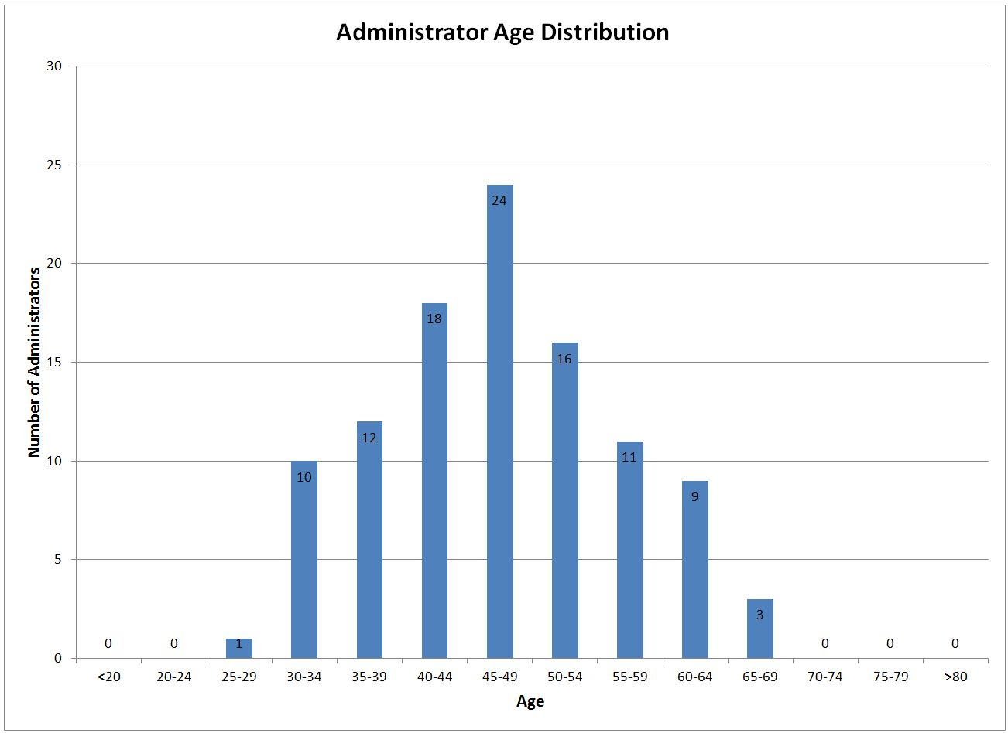

Note: The number in each bar is the actual number of administrators in the School Division.

Building-level administrators (principals, assistant and associate principals, guidance directors, and athletic directors) are also eligible to retire with unreduced benefits once they have at least 30 years of service with VRS and are at least 50 years old. The table below shows the actual number of full-time building level administrators who have or will have 30 years of service with VRS by the end of each school year. The number in the current column is the number of building level administrators working for the Albemarle County Public School Division who were eligible to retire with full benefits at the start of the 2012-2013 school year. This underscores the need to focus on planning for retirements in the upcoming years. Overall, in the next five years, 24% of the principals and 17% of the assistant principals will be eligible to retire with unreduced VRS benefits.

Administrators Eligible to Retire With Full VRS Payments
 | Current | End of  2012-13 | End of  2013-14 | End of  2014-15 | End of  2015-16 | End of 2016-17
Eligible to Retire with  Full Benefits | 5 | 1 | 0 | 0 | 1 | 3
Running Total | 5 | 6 | 6 | 6 | 7 | 10

Retention

Retention rates for administrators over the past five years have been between 87.6% and 92.2%. This year’s rate, 89.1%, is lower than last year’s rate of 92.2%. Of the 11 administrators who left the School Division, four were retirees (36.3%).

Summary

Although there was an increase in the number of administrative hires this year, most of these were due to internal moves. Of the 13 administrative vacancies that were filled at the building level, two were external hires, six were a result of promotions and five were the result of transfers. A continuing area of concern is the number of building-level administrators who could retire within the next five years. Of the six eligible to retire with full retirement benefits at the end of the 2012-2013 school year, three are principals and three are assistant principals. Additionally, continued efforts will be made to attract minority candidates for building-level administrative positions. A particularly positive statistic is the number of minority building-level administrators. About 26% of the School Division’s assistant principals are minorities, while 20% of the principals are minorities. These percentages exceed the established goals.

Classified Staff Report
Recruitment and Selection

Classified employees include all the non‐teacher and non‐administrative positions in the School Division. Examples include all non‐administrative employees in Transportation, Building Services, Child Nutrition, and Extended‐Day Programs. Office associates, school nurses, and teaching assistants (TAs) are also considered classified employees.

From July 1, 2012 through September 30, 2012, the Albemarle County Public School Division hired 123 classified employees. Classified employees are hired throughout the school year, while most teacher and administrative hiring occurs July 1 through September 30. As the numbers in the table below indicate, there has been a decrease in the number of classified employees hired this year when compared to the last three years. It should be noted that the large number of hires in 2009 was due in part to the large number of vacancies resulting from the retirement incentive offered at the end of the previous school year and the fact that there were two dozen frozen positions from the 2008 year that were filled in 2009.

Classified Staff New Hires 2008-2012
2008 | 2009 | 2010 | 2011 | 2012
92 | 172 | 149 | 135 | 123

Minority Staffing

The School Division continues to recruit and hire qualified candidates from all ethnic groups. The following graph provides a breakdown of the School Division’s classified staff population compared to the County’s overall population and the School Division’s student population.

Retirements

Since September 30, 2011, 16 classified employees retired compared to 25 retirements the previous year. As the chart below indicates, retirements in 2009 were considerably higher than in other years. This can be attributed to the retirement incentive offered that year to all eligible employees.

Classified Staff Retirements 2008-2012
2008 | 2009 | 2010 | 2011 | 2012
23 | 66 | 13 | 25 | 16

As the graph below indicates, the largest number of classified employees is in the 50-54 age group. It should also be noted that 50% of the current classified employees are age 50 or older. During the next five years, there are only 13 classified employees who will be eligible for unreduced VRS retirement benefits. This may be a reflection of the fact that less than 50% of classified employees are full-time employees. It is interesting to note that of those 13, eight are eligible to retire with unreduced retirement benefits at the end of the 2012-2013 school year.

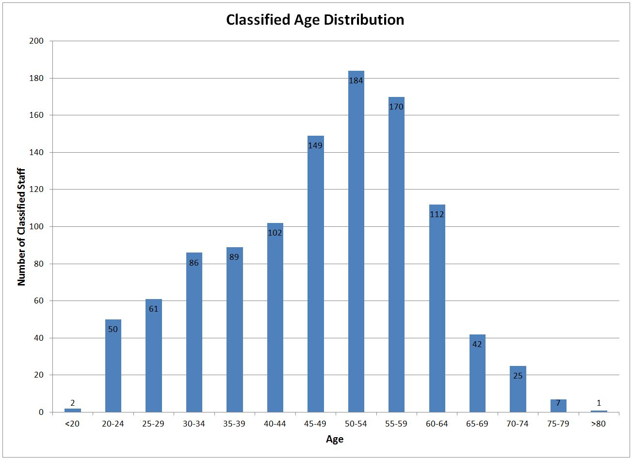
The cumulative number of classified employees (both full and part‐time) eligible to take advantage of the Voluntary Early Retirement Program (VERIP) over the next three years is as follows:

- June 2012: 216
- June 2013: 241
- June 2014: 250

Retention

Retention rates for classified staff over the past five years have been between 79.4% and 83.5%. This year’s retention was 81.2% compared to 79.4% last year. The number of retirees decreased from 25 to 16 and the retention rate increased. It is important to continue to focus on retention by:

- Improving communications within work groups and among employees
- Providing training and development opportunities
- Increasing participation in the exit process to identify possible areas to target retention initiatives
- Reviewing data from employee climate survey to focus on employee engagement
- Providing training to supervisors/managers to increase skill‐sets in core competency areas

Of the 202 classified employees who left the School Division from October 1, 2011 through September 30, 2012, 29% had less than one year of experience with the School Division. Although this is a 14% increase from the previous year, it is a 16% decrease from 2009-2010. Of the employees who left the School Division, 41% were Teaching Assistants. Overall, Teaching Assistants represent 32% of the classified workforce. Of those, nearly 67% are part-time employees. Seventy-one percent of the departing classified employees were at pay grade 6 or less. Throughout the School Division, about 59% of the classified jobs are at a pay grade of 6 or less.

Summary

Overall, the number of classified employees hired into the Albemarle County Public School Division for the 2011-2012 school year is down from the three previous years. Consistent with national trends, an area of concern for the School Division is the number of classified employees who are eligible to retire within the next five to ten years, as illustrated by the graph of employee ages. Thirty-three percent of the classified employees are at least 55 years of age. The low retention rate is also an area of concern. Turnover is costly because in order for new hires to be able to successfully meet job requirements, extensive training is needed.
Exit Surveys

Survey data was collected for employees who left the School Division between October 1, 2011 and September 30, 2012. Human Resources staff made multiple attempts to contact exiting employees to collect data. One-hundred and thirty-three (133) employees (41% of all those exiting) responded to the survey. Sixty nine percent (69%) of the departing teachers and 25% of the departing classified employees completed the survey.

The findings of the exit surveys indicate that 84% of the respondents were favorable in regard to their overall work experience in the Albemarle County Public Schools. Only 8% of the employees responded that their overall experience was unfavorable and 8% were neutral. This is a 3% decrease in the overall positive responses when compared to the responses from 2010-2011 surveys and only a 1% increase in the negative responses. Each responding employee was asked his/her primary reason for leaving from among the following and was allowed to select only one response: salary/benefits package; relocation; retirement; lack of training or career opportunities; leaving profession; supervision/management issues; or reasons external to the system (i.e. personal). Survey results are shown below.

Exit Surveys: Employees’ Primary Reasons for Leaving
Reason | Classified/  Administration (55)* | Teachers (75)* | All Employees (133)**
Reasons external to system | 31% | 24% | 27%
Retirement | 16% | 36% | 27%
Relocation | 9% | 20% | 15%
Salary/Benefits Package | 15% | 4% | 9%
Supervision/Management Issues | 22% | 11% | 15%
Lack of Training/Opportunities | 5% | 1% | 3%
Leaving Profession | 2% | 4% | 4%
*Number of respondents for this particular survey question
**Three employees did not self- identify as classified/administration or teacher

As in the previous years, work satisfaction scores among exiting employees remained relatively high at 80%. Pay/benefits is still an area of dissatisfaction with only 61% favorable and 23% unfavorable. This dissatisfaction may be linked to the fact that School Division employees have not received significant pay increases for the last four years. According to survey results, the largest percentage of classified staff left the School Division due to external factors. Survey results also showed that highest percentage of teachers left due to retirement or external factors. Teacher response to work satisfaction increased 6% to 87% positive while classified was 72% positive, a 5% decrease. Overall, favorable responses have remained relatively stable the last several years and have not shown any significant changes.

Aspect of Employment | Exiting Employees Favorable Response
 | 2009-2010 | 2010-2011 | 2011-2012
1. Work Satisfaction | 78% | 79% | 80%
2. Work Distribution/Schedule Flexibility | 73% | 66% | 67%
3. Pay/Benefits | 57% | 57% | 61%
4. Training and Development | 60% | 60% | 63%
5. Career Advancement Opportunities | 48% | 46% | 42%
6. Supervisory Consideration | 61% | 67% | 65%
7. Work Group Communication | 62% | 66% | 60%
8. Organizational Culture* | 44% | 55% | 58%
* Organizational Culture measures how the respondents feel about the organization’s direction and its employees.

Compensation and Benefits

Joint Boards Adopted Total Compensation Strategy

The School Board and Board of Supervisors’ Total Compensation Strategies are to target employee salaries at 100% of the competitive market median, teacher salaries at the top quartile, and benefits slightly above the market. The Joint Boards follow a process to establish the annual merit increase, teachers’ step and scale increases, and classified salary scale adjustment.

This past year, the General Assembly enacted a variety of changes to the retirement plan administered by the Virginia Retirement System (VRS). These changes included requiring current employees of local governments and school divisions to pay a 5% contribution to VRS by no later than July 1, 2016 and for local governments and school divisions to provide employees with a salary increase to offset the cost of the employees’ VRS contribution (the “5 and 5 Requirement”). The Boards approved the 5 and 5 requirement in FY 13.
Prior to the VRS changes being enacted by the General Assembly, the Boards approved a 1% general increase for employees. Although the 5% VRS-related salary increase covered the required VRS contribution, the 5% salary increase is subject to FICA, thus offsetting some of the 1% general salary increase. Therefore, the full benefit of the 1% salary increase was not realized as the Boards had planned when the budget was adopted. Non-VRS eligible classified employees received the planned 1% general increase, and non-VRS teachers’ scale and step was built on an increase of 1.95%.
Classified VRS-eligible employees received a 6% increase (5% for VRS plus the planned 1% general increase). The teachers’ scale increase varied based on step and scale, with a 6.95% increase applied.

Long Term Classification Plan

To ensure that positions are appropriately classified, HR began comprehensive reviews of all departments on an ongoing basis in July 2004. Priorities are based on identified internal equity issues, substantial changes in position descriptions, and market data. This year, all positions in Transportation Department were reviewed for appropriate classification.

Benefits Administration

The School Division offers a wide range of benefit options that promote a healthy lifestyle and contribute to financial stability. Benefits offered include: medical, dental, deferred compensation, flexible spending accounts including use of a debit card for medical expenses, optional life insurance, direct deposit, family medical leave, employee discounts, paid leave (annual, sick, sick leave bank, etc.) employee assistance program (EAP) and employee-paid long term disability insurance. This year, a new EAP vendor was selected (Optima EAP), allowing for enhanced services for employees and their family members at a lower cost. Pension and life insurance plans for full‐time employees are offered through the Virginia Retirement System (VRS) and for part‐time employees through other vendors.
To increase employee understanding and appreciation of their benefit package, HR continues to refine the online open enrollment website and communicate to employees through various methods, including:
- Offering benefits orientation, benefits refresher workshops, and open enrollment information sessions for both groups and individuals
- Information on the website/intranet
- Financial education and pre‐retirement seminars, as well as individual retirement planning consultations
- Monthly on‐site availability of our deferred compensation vendor representative and informational workshops

This year, HR focused on obtaining employee feedback on the benefit programs by conducting a survey and focus groups. This information is used to guide the design of our benefit programs.

Health, Safety, and Wellness

Efforts in the areas of occupational health, safety and wellness continue to become part of the culture for the School Division.

Occupational Health & Safety: Employee teams are an integral part of ensuring safety in the work environment. Two departmental teams, Building Services and Transportation, have dedicated their time to identifying and preventing workplace accidents for their staff. In 2012, Building Services had a 90-day period that was accident free. In addition, there was a class offered at the Making Connections event on “Teacher Safety in the Schools” and there are plans for more educational opportunities in 2013.

Wellness: A variety of wellness programs have been offered at locations throughout the County, including flu vaccinations at each school and department, Mobile Mammography within each geographic feeder pattern and at the central office location, and the Medically Supervised Weight Loss program. In addition, the Wellness Program had a significant presence at the Making Connections event. There were classes offered on wellness benefits, yoga, ergonomics, nutrition, stretching, and managing change. In addition there were seated massages, mini health screenings, and vendor displays including Optima EAP, Coventry Health, ACAC Fitness and Wellness and, Albemarle County Benefits.

A variety of additional wellness programs have been offered at various locations throughout the County. Examples include:

- Weight Watchers at Work
- Smoking Cessation Program sponsored by our local Health Department
- FIT Extension sponsored by the Virginia Cooperative Extension Office
- Charlottesville’s Women’s and Men’s 4‐Miler events

Training

System‐wide, professional development activities are offered for teachers and administrators through the Albemarle Resource Center (ARC). Because there were very few professional development opportunities offered for classified employees, in 2006 the School Division began providing funding for classified employees’ professional development through courses offered by Human Resources' Organizational Development team. For fall 2010 and spring 2011, School Division classified employees attended 96 different classes, totaling more than 1,122 hours of class time. Classes included:
- How to Do a Project Post-Mortem
- Intermediate Outlook 2007: Email Management and Efficiency
- How to Reward and Recognize Employees
- Cardio Pulmonary Resuscitation
- Editing and Using Pictures in Microsoft Office 2007
- Leadership Foundations
- Teamwork 101
- Customer Service and the FISH Story

In addition, Human Resources regularly offered and provided training to hundreds of employees in the following subject areas: new employee orientation, on-line annual training, retirement planning, interviewing (legal issues and interviewing skills), safety awareness/OSHA training, and sexual harassment training.

Annual Service Awards

The School Division annually recognizes employees for their continuous years of service with the School Division. As in years past, employee recognition was conducted at the employee's school or department. Feedback has indicated that this personalized form of recognition is greatly valued by employees. All recognized employees received a framed certificate. In addition, recognition gifts were presented for 10, 15, 20, and 25+ years of service as follows:

- 10, 15, and 20 years of service: employees received a gift
- 25+ years: employees chose from a selection of gifts that best suited their preferences
- Employees who had the greatest length of service and reached a milestone this year were recognized with a special presentation and gift at the Employee Recognition Ceremony held at the County Office Building.

This year, 420 employees were recognized for their service milestones that occurred between October 1, 2011 and December 31, 2012. A change was made this year to the recognition period to switch to a calendar year cycle. This allows for awards to be delivered to the departments in the winter so that they can more closely be presented to the anniversary date. Employees with anniversaries occurring between October 1, 2012 and December 31, 2012 were added to this year’s presentation. Human Resources received positive feedback from administrators and staff on this change. Of these 420 employees, 180 were recognized for 5 years of service, 87 for 10 years, 47 for 15 years, 51 for 20 years, 30 for 25 years, 18 for 30 years, 5 for 35 years, and 2 employees were recognized for 40 years of dedicated service with the Albemarle County Public Schools.

Employee Engagement

Attracting and retaining high quality personnel and a commitment to building the quality of our own workforce is essential. To accomplish this strategy, a team of central office staff devoted to studying employee engagement researched and selected items for an “Engagement Survey” from the K12 Insight item bank. A thirty-three (33) item tool was developed to assess employee engagement factors, self-perceptions of proficiency with Teacher Performance Appraisal standards and external standards, and perceptions of professional development needs. This survey was administered to all school division employees via an e-mail link from February 20th through March 2, 2012. One thousand, one hundred, and seven (1,107) of our 1780 plus employees responded for a 62% response rate.

Rather than simply jumping to conclusions and using a blanket approach to boosting engagement, we will be unpacking the results of the survey to seek employee input on how to best plan for changes. We will follow the continuous improvement model of planning before doing, studying results from changes and acting on what we find.

Here are some examples of where we are excelling: (% indicates favorable rating)
I feel satisfied when I do my job well 96%
I love seeing the results of my work 96%
I feel enthusiastic about my work 91%
Potential Opportunities for Improvement (% indicates unfavorable rating)

I feel recognized for good work 17%
My Supervisor enables effective communication 17%
We have an action plan in place to get us to our vision 18%

Employee engagement, a School Division priority, continues to be an area of focus. We will work to increase employee engagement by reviewing and sharing best practice recognition (both within the Division and market practices), providing training for supervisors on reward, recognition, goal setting and feedback to employees and emphasizing goal setting alignment with Division strategic goals.

Going Forward
Human Resources is committed to helping the School Division accomplish its mission and support the overall strategic plan and will continue to work to meet identified strategies as indicated.

For Goal 3: Recruit, retain and develop a diverse cadre of the highest quality teaching personnel, staff, and administrators. These efforts include:
- Developing and implementing a comprehensive plan to recruit and retain the highest quality teaching personnel, staff and administrators
- Supporting the establishment of an individual goal for recruitment and/or retention to address the diversity needs for each school
- Exploring and initiating innovative recruitment strategies such as use of social media to support recruitment efforts
- Increasing the ratio of minority hires to minority exits for teaching and for supervisory/leadership positions
- Continuing to engage with principals regarding staff diversity as related to hiring needs and practices
- Providing effective training and development for classified staff to meet current and future needs
- Continuing to meet market targets for the County’s total compensation strategy, to include evaluating market competitiveness of salary and benefit programs
- Implementing desired voluntary benefits, based on employee feedback, such as long term care, long term disability and offer enhanced options to existing benefits, such as the flexible benefits account card
- Addressing areas of improvement identified in the exit survey and upcoming climate survey
- Ensuring performance management systems are aligned with Division goals and state standards to include the implementation of new administrator, teacher, and teaching assistant performance appraisals.
- Continuing to partner with local organizations and colleges/universities regarding teacher education programs
- Developing an internal pool of administrator candidates
- Implementing an improved systematic screening plan for teacher candidates using a new on-line application system
- Implement effective strategies to increase employee engagement.

For Goal 5: Establish efficient systems for development, allocation and alignment of resources to support the Division’s vision, mission, and goals. These efforts include:
- Conducting reviews of pay practices to ensure compliance and create organizational efficiencies
- Establishing close business partner relationships with schools and departments through realignment of HR resources
- Improved efficiency through conversion to direct deposit pay for all employees in 2013
- Continuing to create efficiencies with new Human Resources/Payroll System (Great Plains)
- HR and Transportation sharing joint goal for increased employee engagement

